The following is from the program at the building dedication service held April 2, 1995

Today is a very special day for Mt. Gilead, a day of dedicating our new building to God’s glory and service. It is a day of giving praise and honor to our Lord and Savior.
We feel very fortunate, very thankful and very humble that God has permitted us to have such a beautiful place to worship. It is with great humility that we say on this April 2, 1995, “Our cup runneth over.”
Since the beginning of our church in 1879, God has been in our midst and continues to guide our progress. God’s hand at work can be seen throughout the entire process of planning for our new building and its construction.
We believe, as David did, that God’s house should be the very best in the community and we, under the leadership of the Holy Spirit, have built the best we could.
Our old building, which was built in 1926, with additions through the years, has served us well. Many of our church family were saved there and all of us grew spiritually within her walls. But the time had come when we had outgrown her space.
Our classrooms in the basement were small and in bad condition; two classes had met in a trailer since 1989; and the Men’s Class, since its beginning, had met on the church bus. It was time for more space.
After much prayer, many long hours of planning and a lot of hard work, today we have this beautiful sanctuary which seats 330 people and adequate classrooms for all Sunday School Classes. We have enough rooms for our Mission Classes to have their own rooms.
Our Building Committee was elected in January 1989. After several months of praying, planning and working, the committee presented proposed plans to the church body for the new building in November, 1989. These plans were displayed for time for everyone to view.
In December of the same year, a Finance Committee was elected.
These plans and projected costs were not presented to the church body for a vote until January 27, 1991. The building project was defeated with 52% of the church body voting against it.
Disappointed and discouraged, but not defeated, the building committee began new plans.
After much more prayer and hard work, plans were again presented to the church on October 25, 1992. At this time, the church body approved the plans. The building would be fifty feet by ninety nine feet, with full basement containing eighteen classrooms and bathrooms.
Many details, including the financing, needed to be worked out before the building could actually begin.
The church body voted not to begin construction on the new building until the amount in our building fund reached $50,000.00. An additional borrowing limit of $200,000.00 was set.
A problem arose when the Finance Committee began to investigate financing for the new building. Two old deeds to the church property read “should the church cease to be a church, the property would automatically revert back to the family which gave the land.” The bank required a notarized release from each heir of the two tracts of land.
The heirs of one tract, Mrs. Mina McCaslin, Mr. Leroy Coffman and Mrs. Margaret Volner, readily signed the release. The other tract had minor as heirs. To obtain a release from them required litigation, so the parsonage was used as collateral instead.
Trustees were elected to take care of the loan. Our loan was finalized May 24, 1994 at First Tennessee Bank of Jackson.
Houston Jordan was elected to serve as Treasurer of our Building Fund.
Our Decorating Committee was elected to select carpet, furniture and other fixtures.
In order to save as much money as possible, the Building Committee served as General Contractors.
Our architect was Ms. Kim McGoughy and only charged $1000.00 instead of a percentage fee they usually require.
On May 5, 1994, the first grade was shot! Paul Gaston began digging the basement on May 9, 1994.
More than five years had passed since the first steps toward a new building began, but the dream was finally becoming a reality. Many barriers had been crossed, many obstacles overcome; but thanks be to God, the building had begun. It was a time of great joy and excitement for us all.
Our groundbreaking ceremony was held on June 19, 1994.

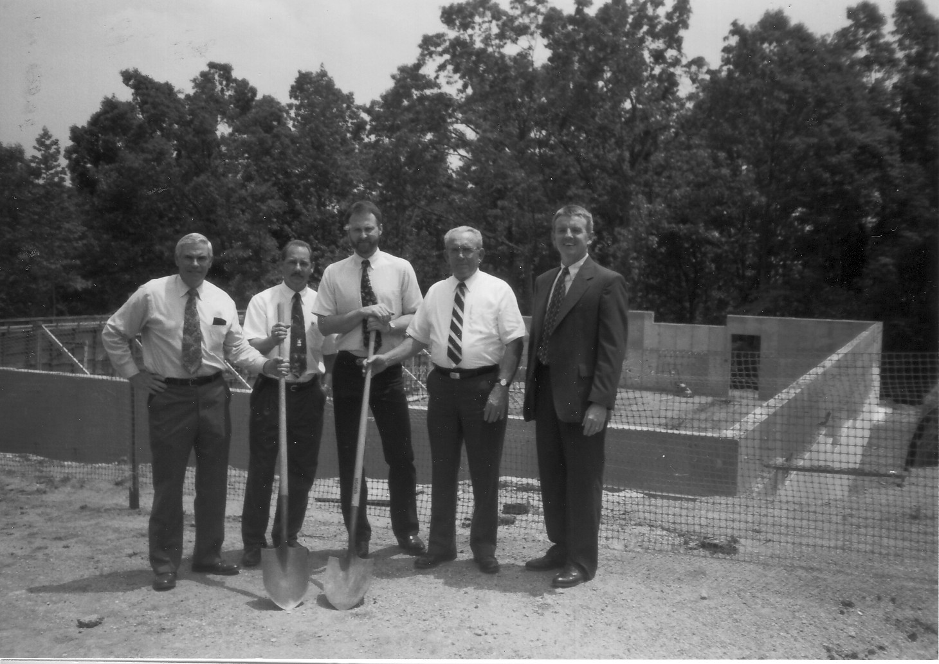
Roy Hutson, James Oswalt, Gary Bohn, Houston Jordan & Bro. Phil Mitchell

GOD’S SPECIAL PEOPLE
God moves in mysterious ways and He knew we needed help with our building. He had His Special Ambassadors waiting for our call. They were the Volunteer Christian Builders.
They are a group of Christians families based in Texas who go somewhere every year the first two weeks in July to help a church with a construction program.
Some of these people are retired, but many of them take their vacations at this time to help build. They make it a family affair and the women and children work in building too.
Up until March, these people did not know where they would be going this year; they only knew God would send them somewhere. Bro. Phil hesitated about calling them fearing that if they came to help us; another church would be left out. When he found out they did not have a place to go, he knew their job was to “come into Mt. Gilead” and help us.
Faithful to their calling, these people promised they would come. All we had to do was provide a place to park their motor homes, travel trailers, etc. and two meals a day.
Many wonder and ask why these people spend their vacations each year working for people they do not even know. Mr. Doug Eudaly, their spokesman said, “We do this because of our love for God and what He has done for us. I believe the best way to spread the gospel is through the local church, and they can do it best when they have adequate
Mr. Harlan Joyce at the age of 78 said, “I’m not crazy, I’m doing work for the Lord. The good Lord gives me strength to do what I do.”
Jerry Farrier said, “When people ask about our vacation, and we tell them, it opens so many doors to so many hearts that can’t be touched otherwise.
Bill Dawkins said, “It’s just a revival time for us. We get all fired up and ready to go.”
These workers began arriving on Thursday, June 29th and by Sunday Morning; our church yard was filled to capacity with motor homes, travel trailers and 59 workers. What a sight for the church and community to witness! These people attended church with us Sunday morning, July 3rd.

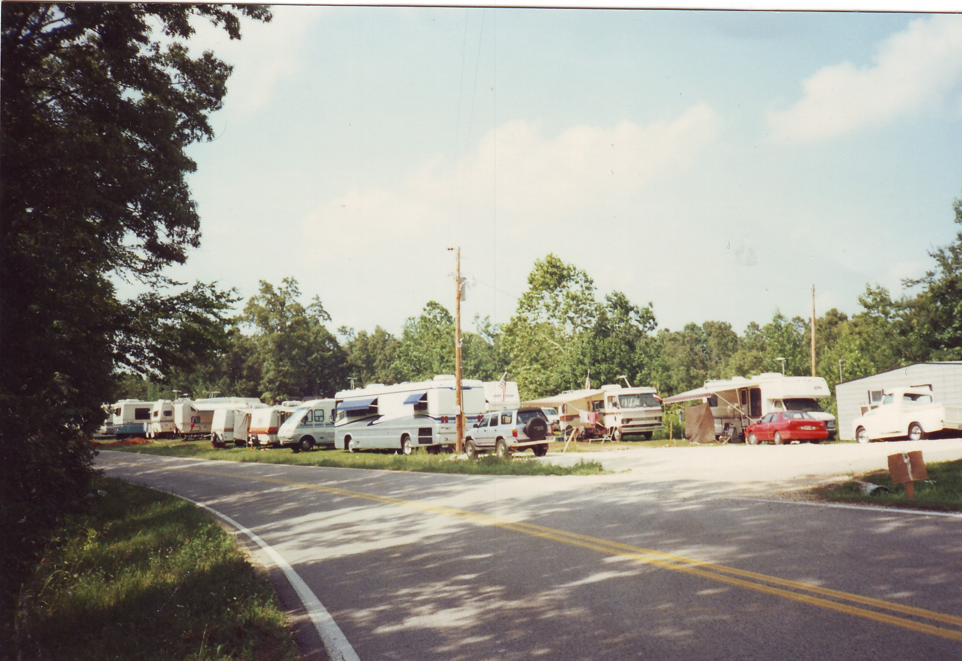
Monday morning, at seven sharp, work began! Most of our active church members were “on the job with a mind willing to work.” It was the July 4th holiday and people were off from work. Many of our own members took their vacation these two weeks so they could work on the building.
There were at least 130 people eager to work. Many of our church women, under the leadership of Brenda Coffman, were in the kitchen preparing food for everyone.
The church grounds were literally covered with people. Joining hands and hearts on the subflooring, the workday began with prayer, as it did every day thereafter. It was an unforgettable day. People passing by were amazed and slowed down to get a better view of this unusual scene. Many stopped to see exactly what was happening.
A tent was set up where the men did the sawing and women and children carried the lumber to be sawed; and then on to the builders. We all felt great tranquility and peace and harmony that day. It was as if God was pouring out an extra helping of blessings on all of us.
It was hot! The temperature was in the nineties. Needless to say, work had to be slowed down a bit. But in spite of the heat, and much to our amazement, the four walls of our new building were in place by six o’clock.
Raising these walls was an exciting and thrilling experience none of us will forget. We all shared Bro. Phil’s statement when he said “this is the best 4th of July I’ve ever had.”
The Volunteer Christian Builders were really patient with those of us who knew nothing about building, but still wanted to help. They permitted as many as could to help with raising the walls. With God’s special care over us, none of us were hurt seriously.
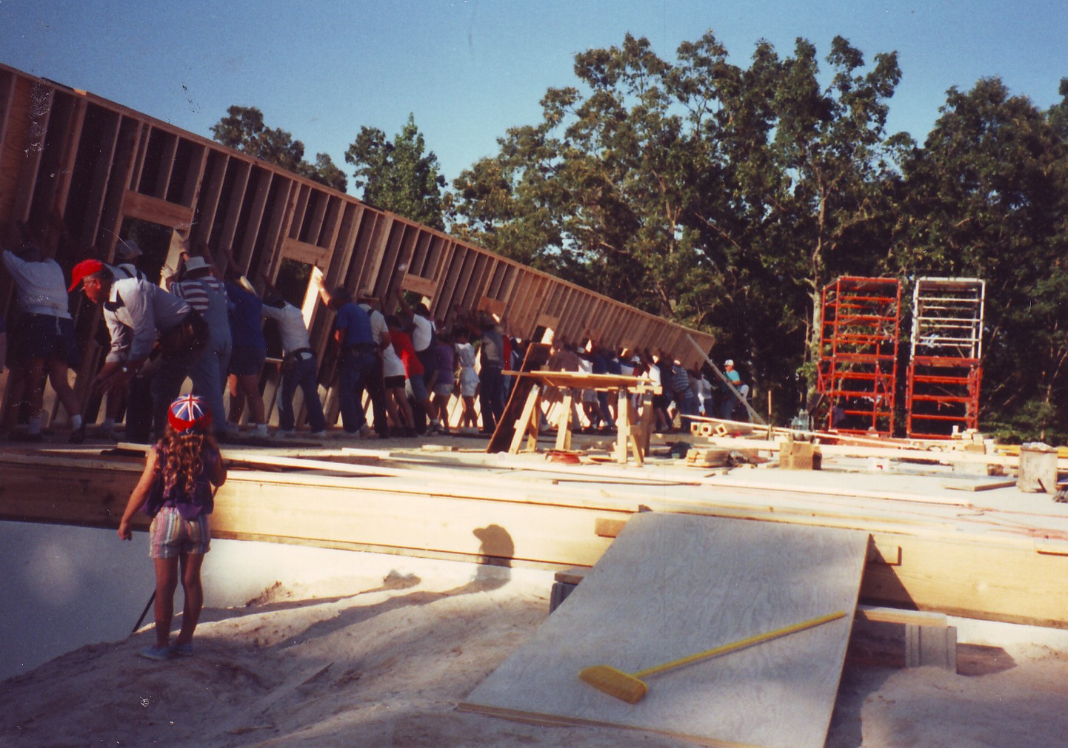
The second day, the trusses were put into place. What a miracle this was! The equipment we had rented to raise these in place did not arrive until eleven o’clock; but by 6:30, all 51 of the trusses were in place. When the last one was in place a Texas flag was stationed on top of the truss by the Volunteers.
Mr. Eugene Spellings, from whom we rented the equipment, only charged us $100.00 instead of his quoted $65.00 per hour fee. He too, was caught up in the unity and harmony of all the workers.

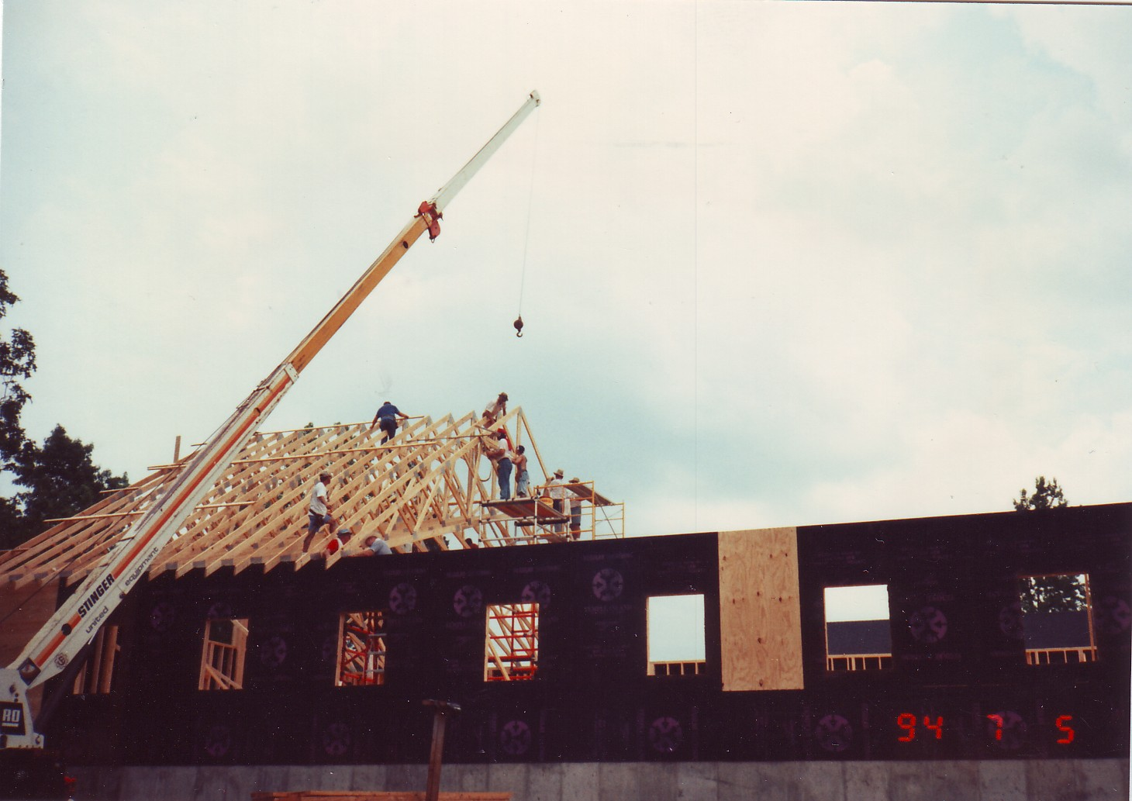
The Volunteers were very hard workers. We considered it an honor to work with them. Our own church family grew closer as the days passed.
Each day at the morning break, a devotional was given by various ones. At one of these devotionals, Anita Bohn and Katrina Oswalt compared the building of Solomon’s Temple with our own church building. It went something like this:
The length of Solomon’s temple was 90 feet, the length of our church is 99 feet; the width of Solomon’s temple was 30 feet, ours 50 feet; the height of Solomon’s temple was 45 feet, ours 30 feet; Solomon’s temple had 300 rulers over it, ours had Mr. Eudaly and his whistle; Solomon’s temple required 30,000 men to get wood, we sent Howard, Charles and Bro. Phil; Solomon’s temple was constructed away from the site so no noise would be made, we had power saws, hammers and nail guns; Solomon’s temple was built with stone and covered with wood, ours is built of wood and covered with stone; Solomon’s temple took seven years to build, our will take seven months; Solomon’s temple was covered with gold when it was finished, our will be covered with love; and the Spirit of the Lord filled Solomon’s temple when it was finished, but the Spirit of the Lord filled our church during the service Wednesday night.
While construction was underway outside, the women in the kitchen were also very busy.
All the women share the same feeling as that expressed by Sharon James when she said, “We may not have driven any nails, but we helped build our building.”
Our women worked hard in the kitchen providing food and drink for the workers. Sandwiches and desserts were provided for lunch and a well-balanced meal was served at supper. The women also helped provide refreshments for the morning and afternoon breaks.
Our fellowship hall was too small to seat everyone at once, but the food was plentiful and very good.
Our workers seemed to enjoy the meals. The night we had fried chicken, corn on the cob and green beans, one of the workers said, “I thought I had died and gone to heaven and then when those ladies brought out those hot cinnamon rolls, I knew I had.”
Another one of the volunteers thought we should open up “Mt. Gilead Restaurant.”
Almost all our women helped in one way or another. If they could not come and help at the church, they sent food prepared at home. Many came almost every day to help cook, serve and clean up afterwards. Gail Essary made a cake especially for our Texas workers saying “God Bless Texas.”
Our young people worked very hard. Many worked on the building and others helped in the kitchen. They also worked very hard trying to keep everything as clean as possible.
Some of our young people, under the supervision of Judy Meals and Anita Bohn, made a little keepsake to give to the workers.
Also, one of the volunteers, Mrs. Beth Roper and her husband, made and gave the women a Christmas tree ornament in the shape of Texas, which will be treasured reminder that will last through the years.
WBBJ television station did a story of our building efforts in progress. Televisions were brought into the church so that we could watch the news together that evening when the story was aired. The Lexington Progress carried pictures and stories about our joint efforts toward the construction of our new building.
On Wednesday evening our prayer service was held in the new auditorium under construction. Our roof was open, the walls were only studs, and seating consisted of straight-backed and lawn chairs, but God’s presence was strong as we worshipped together.
Bro. Doyle Neal, our Associational Missionary, came and led our singing. Kelly White brought her keyboard and played for us.
Testimonies of God’s blessings were shared by the volunteers and our church members. Some of our youth sang a very appropriate song, “Thank You for Giving to the Lord.”
Many tears of joy and love and happiness were shared by all of us at this service. As we dismissed with prayer, the entire congregation joined hands, forming a circle which encompassed the new building. This service will be one that is tucked into the “chest of memories” of each one who participated.

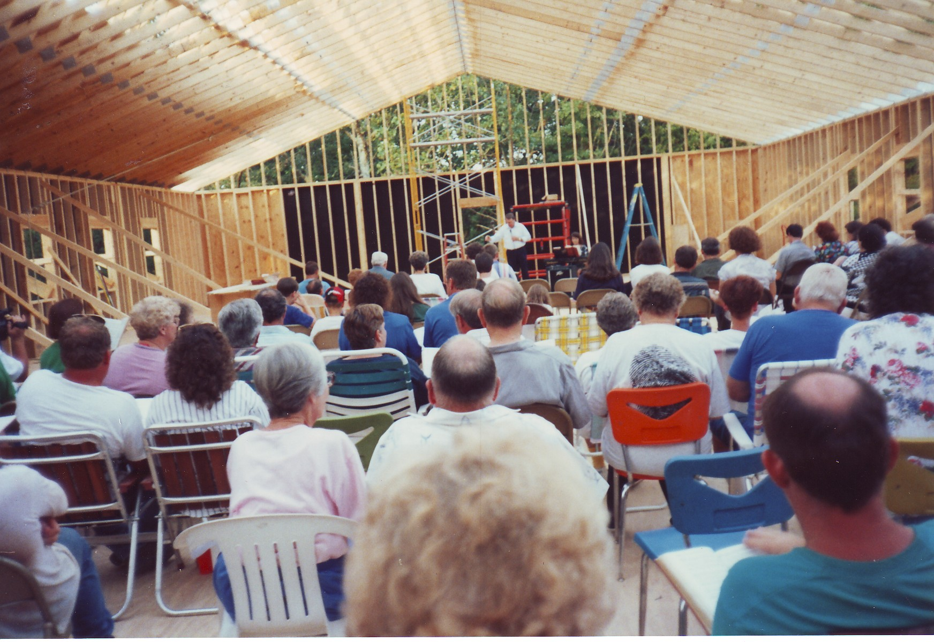
Many of the volunteers and our members wrote scriptures on the inside of the walls and on the subflooring so as we entered the building, we would be “surrounded with scriptures.”
Before the decking could be finished, the rains began. We had rain, rain and more rain. Many stated they had never seen it rain so much in July before. Needless to say, this hindered the progress of our building.
When Friday came and several of the workers had to leave, we really hated to see them go. They had given us so much, their time, their labor and most of all, their love. Friendships had been formed and we had learned valuable lessons in sharing from them.
Though some of the volunteers had to leave at the end of the first week, some of them stayed for a second week. Some new volunteers also came to help the second week. Work was slower and rains continued to hinder the work.

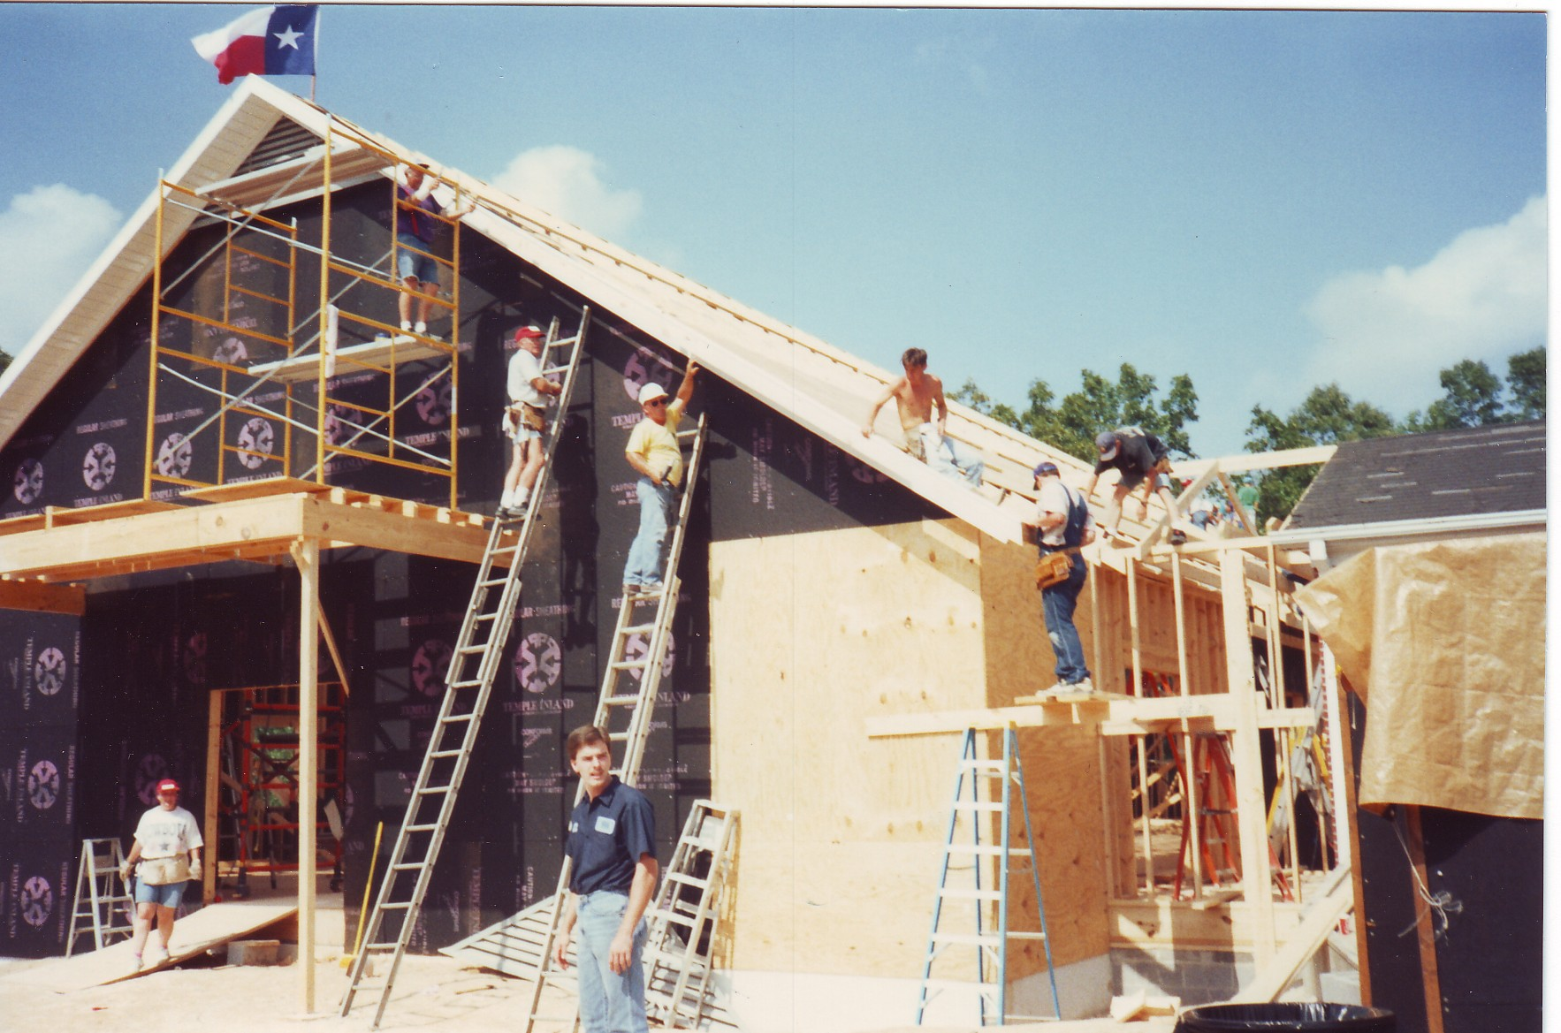
All too soon, it was Friday again, and our volunteers had to leave. Even though we had only known them a short time, we loved them and felt sad at their departure.
So many good things happened the two weeks they were here. Friendships were formed, and a bond of Christian love established between us.
They left us with not only a new building, but much richer spiritually. We saw first hand God’s love in action. They had taught us by their actions the joy of giving of self. We saw God’s people, under His leadership, doing missions.

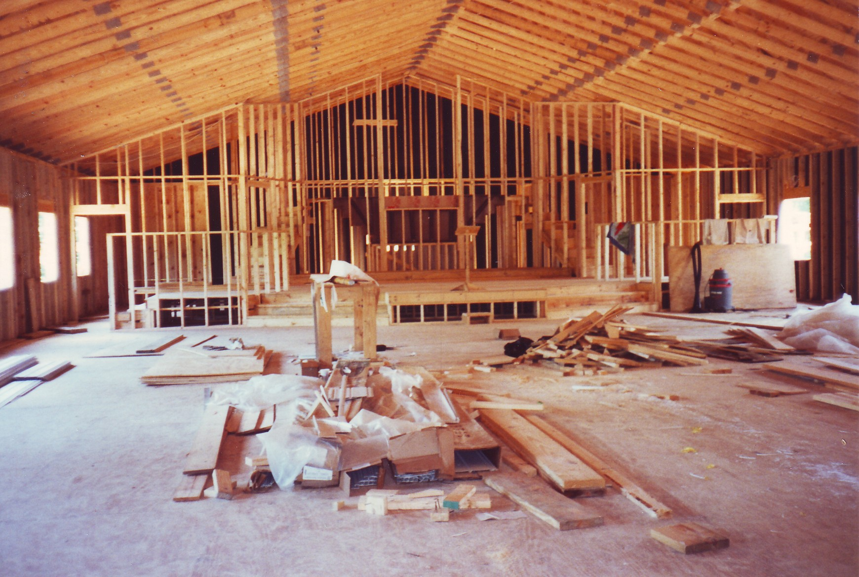
They enjoyed helping us. Several stated they always carried back home more blessings that they gave. Since leaving, some have returned for brief visits to see how the building was progressing. Letters have gone back and forth between our church members and the volunteers. Hopefully, some of them are with us today for our dedication service.
One couple, Don and Jean McClelland, adopted Bro. Phil as their son. She sent him a card this summer with a note inside to “call his mom.”
Our church family was really impressed with the love of God these people displayed. This July, as they continue their work, we will probably see some of our church family joining them.
Since July, work on our building has continued under the supervision of our Building Committee, Roy Hutson, James Oswalt, Houston Jordan and Gary Bohn.
Throughout this building program, there is one group of people we could not have done without; and that is our Brotherhood. They have spent countless hours working and have saved the church many dollars.
Our church body as a whole has been so supportive and has done what they could to keep down the cost.
Enough cannot be said about our Building Committee. These men have spent hours and hours planning, making decisions, contacting workers, overseeing the work, and doing much of the work themselves.
James said “it took a lot of time, work, planning and Tylenol.”
We certainly could not have built at the cost we did had it not been for the dedication of these men. They saved us a lot of money.
Many members did things to keep down cost, the Brotherhood painted the basement, Jimmy White did the wiring for the alarm system and sound system and Jimmy and Houston Jordan did the telephone wiring.
We certainly could not have done without Bro. Phil. He worked very close with all the committees in making decisions as well as doing much of the labor.
A group of people who sometimes are forgotten in a project like this are the ones who have gone on to be with the Lord. Without them, none of this would have been possible.
Wilma Bolen stated “we just know our relatives that have gone on would like this too.” And as we move into our new building, we can’t help but look behind us and recognize and appreciate all those faithful and dedicated saints who down through the ages, spent countless hours and endless work to make sure our generation had a good place to worship.
As our forefathers provided for us, we wish to provide future generations the same.
Because of the delay in getting our pews, we didn’t actually have service in our new building until March 5th. (Our youth did have a portion of our Christmas program in the new building at Christmas.) On our first day in our new building, Megan Blankenship accepted Jesus as her Savior. What a great way to begin in our new building!
Bro. Phil’s sermon topic was “Our Work Has Just Begun.” Hopefully all of us will apply this to our lives and “go out into the highways and hedges and compel them to come in.” People all around need the Lord. We have plenty of room for everyone now.
The entire cost of our building is $267,275.00 as of March 26, 1995. There will be a $9300.00 paving bill plus a few other costs such as bulletin boards for the classrooms.

